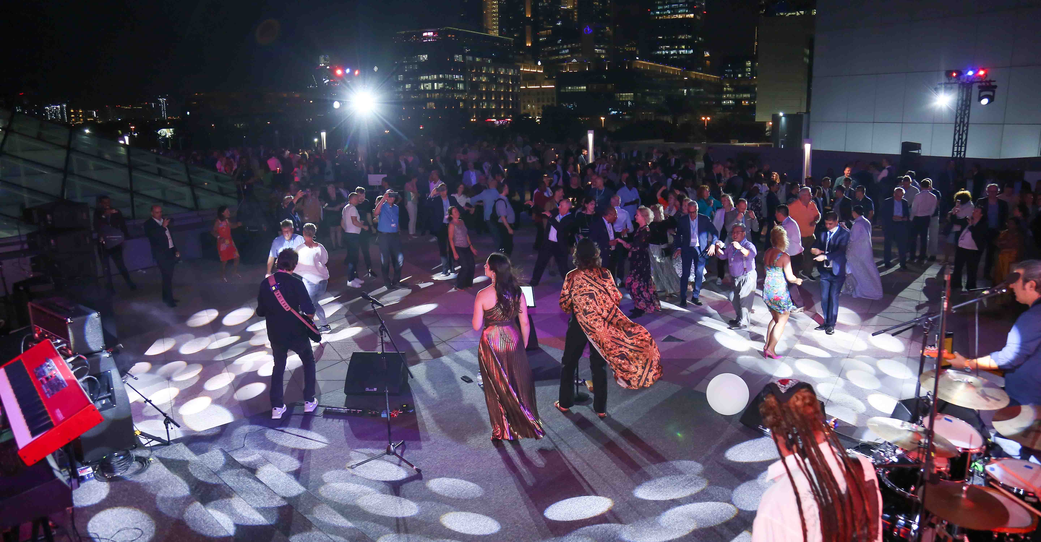WMAS development prototype rocks during World Radio Conference
Sennheiser sponsors live audio technology at the U.S. reception

Wedemark/Dubai, December 2023 – Sennheiser was the official audio sponsor of the United States reception during World Radio Conference 2023. Organized in the opening week of the conference, the event was a resounding success, welcoming more than 1,200 delegates who enjoyed a captivating gig by the Sonic Crusaders. The band used Digital 9000 wireless microphones, with a hand-built WMAS development prototype ensuring crystal-clear digital in-ear audio for the band members. Dubai-based event service provider 3DB, with project manager Stuart Andrews, supplied all audio, video, lighting and stage production requirements for the event.

The WRC U.S. reception included a live concert by the Sonic Crusaders  (Image courtesy of 3DB) | 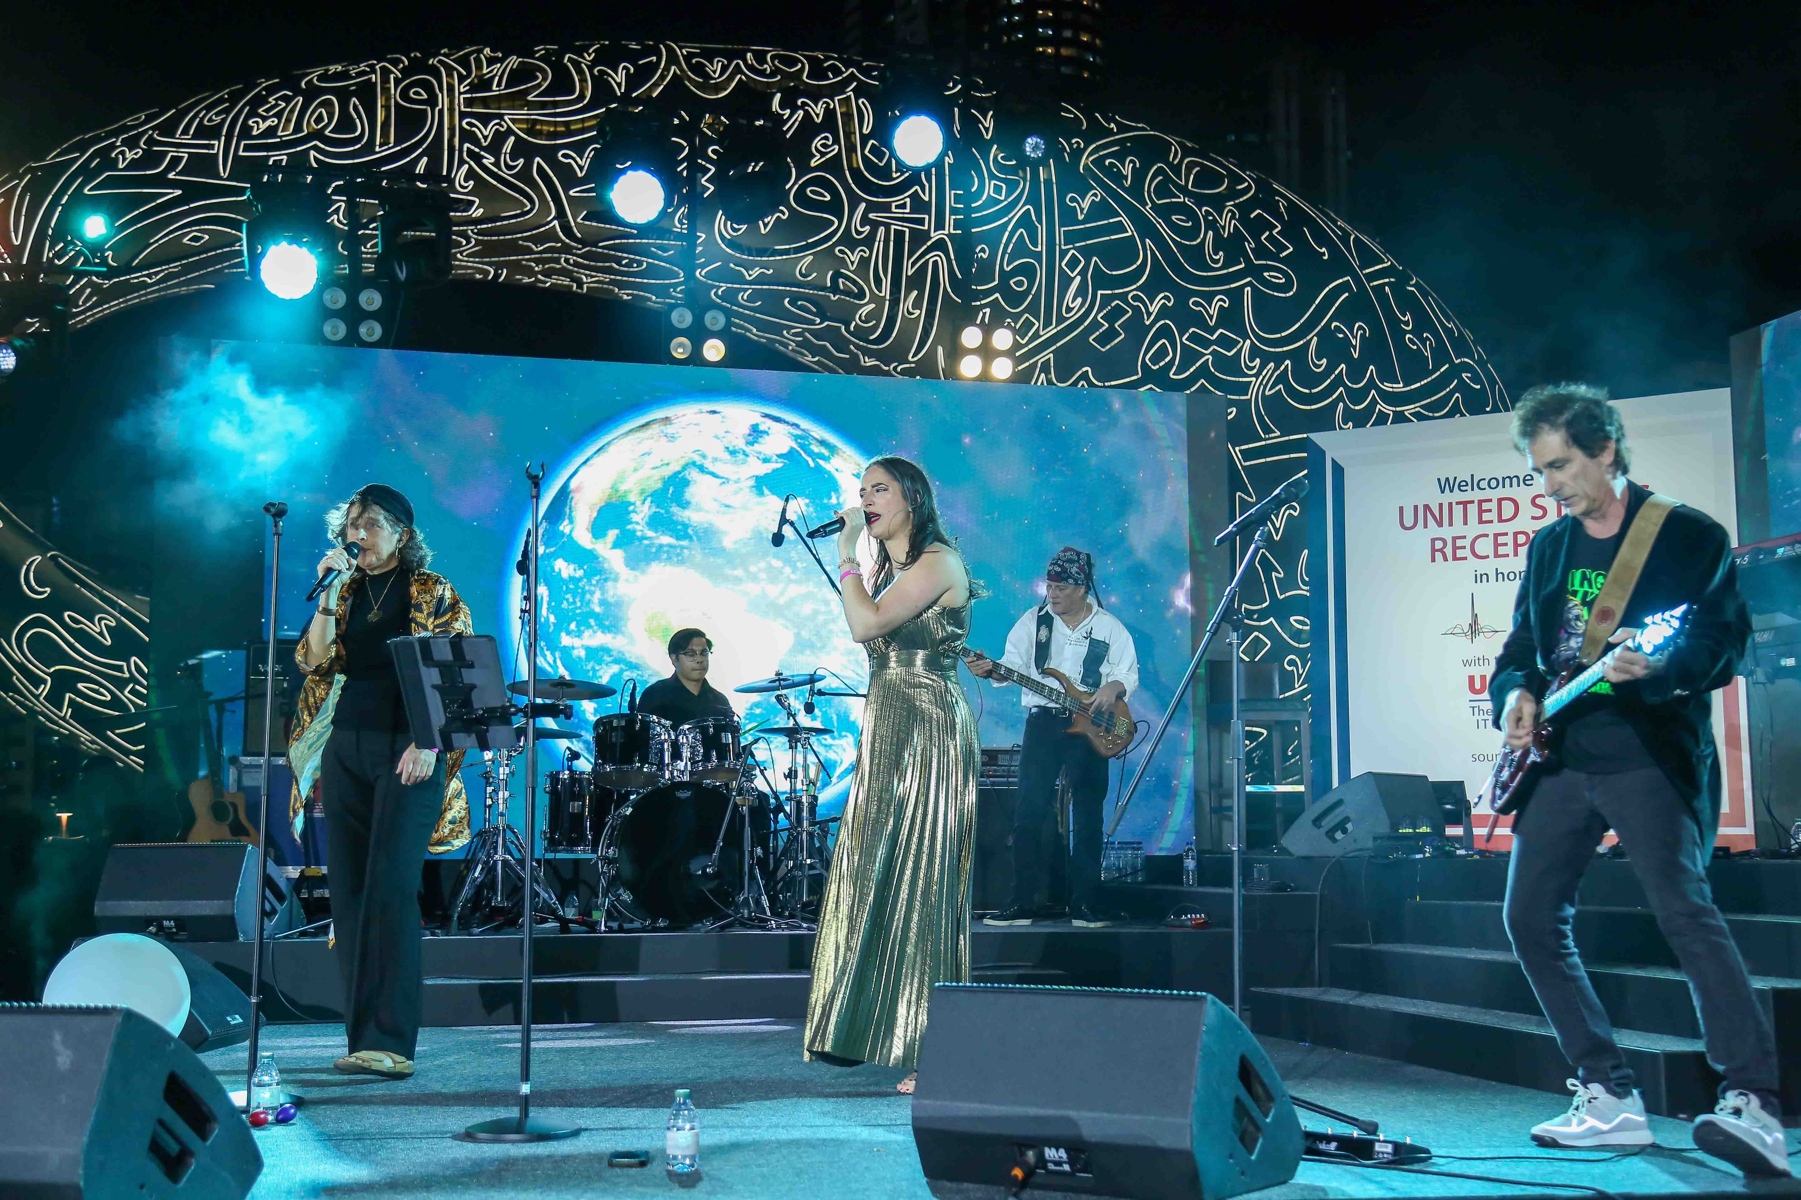

“We are honoured that the U.S. ITU Association (USITUA) selected Sennheiser as the audio partner for its prestigious reception,” says Dr. Andreas Wilzeck, Head of Spectrum Policy and Standards at Sennheiser. “For the show part, we operated a hand-built broadband WMAS prototype and several conventional narrowband digital wireless links simultaneously, proving the effortless co-existence of both technologies.”

A WMAS development prototype was operated alongside conventional narrowband systems  (Image courtesy of 3DB) | 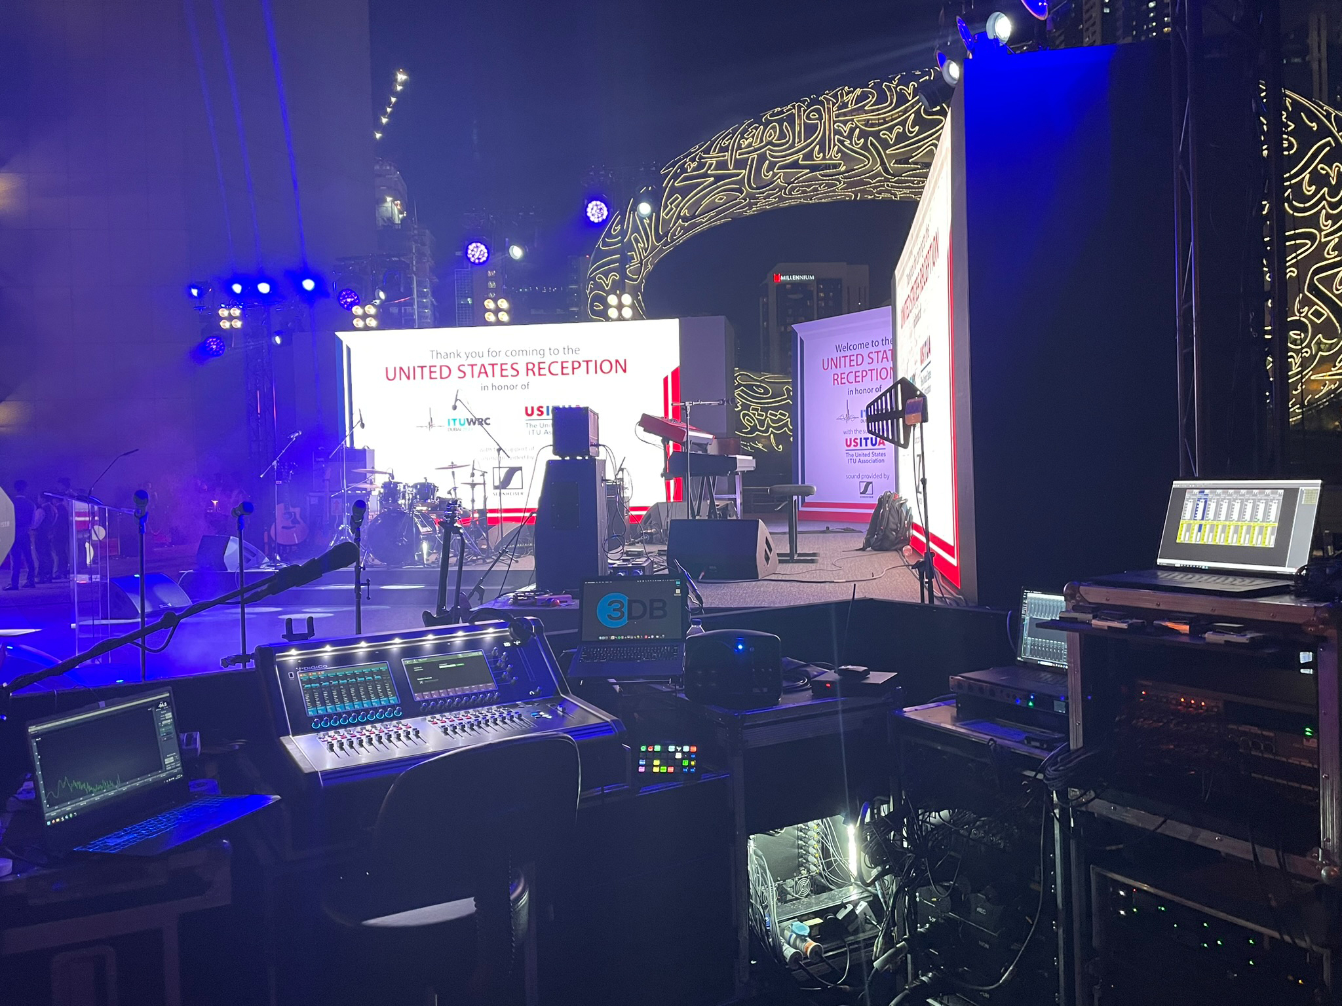

Stuart Andrews, project manager at 3DB: “Thanks so much for the amazing opportunity to work with the Sennheiser team and be able to road test the WMAS technology in a real-life concert environment! We were blown away by the prototype, the concept and design is fantastic, the performance is just ‘next level’. It will be a game changer on so many levels in live audio.”

The United States Reception took place on November 22 on the roof terrace between the twin Jumeirah Emirate Towers (JET), a challenging outdoor location due to the wind conditions. As the main wireless system for vocalists and acoustic guitar, 3DB employed an EM 9046 receiver with seven SKM 9000 handheld transmitters and one SK 9000 bodypack. The two handhelds for the lead vocals were fitted with super-cardioid, high-rejection MM 445 capsules, and the five handhelds for backing vocals with cardioid MD 9235 heads.

Wireless monitor signals were provided by a hand-built WMAS development prototype. Jason Banta, FOH engineer for the event, was full of praise: “The WMAS technology will relieve a lot of pressure on an otherwise loaded RF world. Transmission of the prototype was rock solid with no perceivable latency to my ears. The sonic quality was everything you would want from Sennheiser.”

Jason Banta, FOH engineer for the event  (Image courtesy of 3DB) | 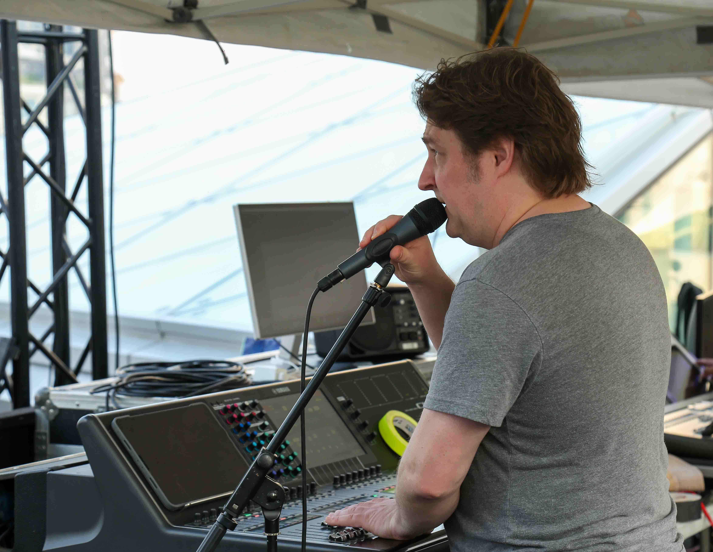

Vocalist Susan Andalaro supported Banta’s praise: “The WMAS prototype delivered the best-quality in-ear monitor signals I have heard to date. I could hear everything the band members were doing with impeccable precision.” Vocalist Vanessa Pare added: ”I was very impressed. The balance between the instruments on the in-ear monitors was exactly what I was looking for, and I did not need to remove the ear pieces at all during the show. The sound quality was very crisp throughout.”

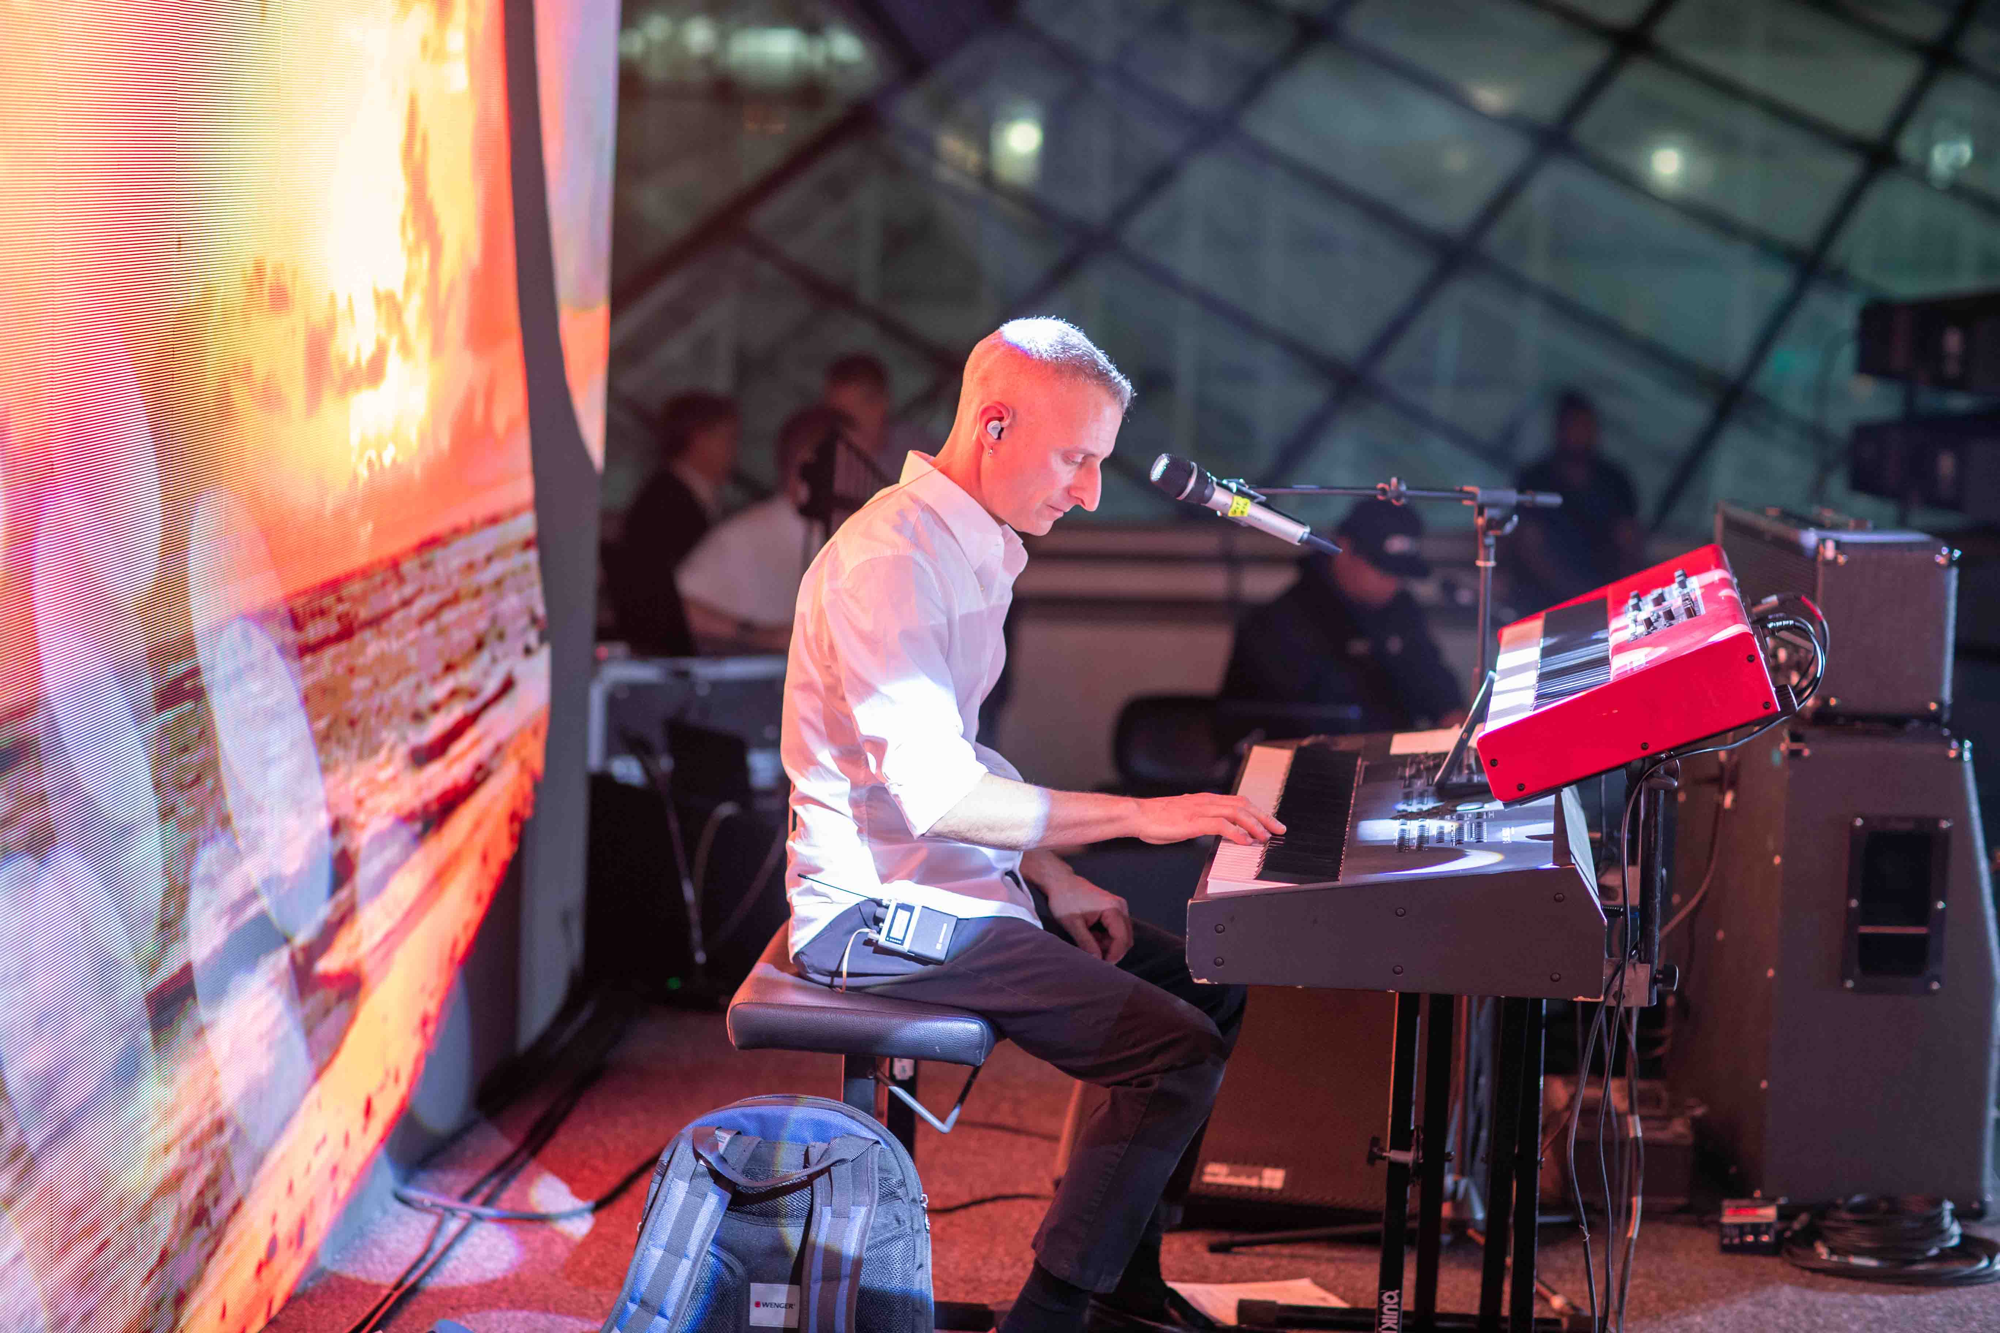 | The WMAS development prototype was employed as an IEM system, with Digital 9000 mics being used for vocals  (Image courtesy of 3DB)

”I had the unique opportunity to indulge in Sennheiser’s new WMAS technology, using it for in-ear monitors. This prototype not only exceeded my expectations but offered a truly immersive and exceptional audio experience. From flawless connectivity and interference-free performance to crystal-clear sound, it left an indelible impression,” sums up Dave Tarzian, the band’s musical director.

Wired evolution microphones captured the drumkit, with e 901 and e 902 on the kick drum, e 914s as overheads, as well as e 904 and e 908 for toms and snares. The two guitar amps were miked with e 906s, while the bass amp was captured by a classic MD 421 II. 3DB also ran two EW-DP systems for the guitarists to connect wirelessly to their pedal boards. This gave them freedom of movement around the stage – and even out in the crowd.

3DB created a wireless pedal board solution with a wireless EW-DP receiver  (Image courtesy of 3DB) | 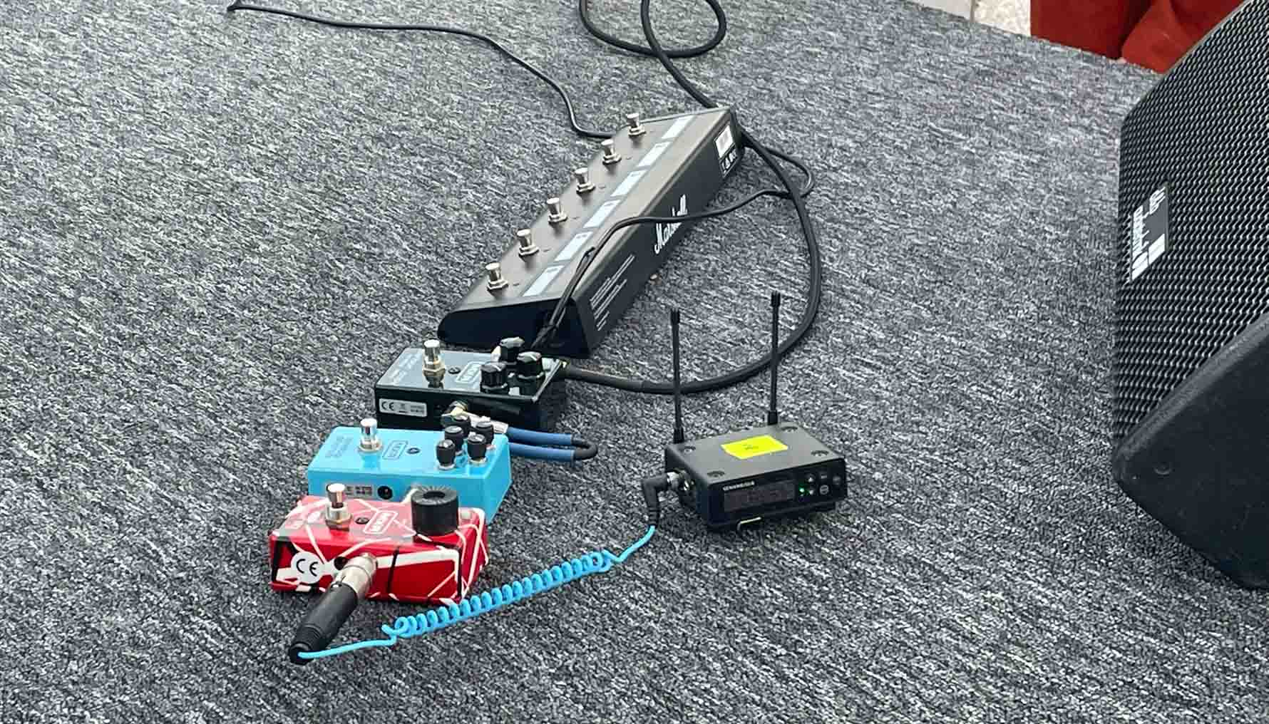

Dr. Wilzeck concludes: “A world radio conference is filled with complex topics and different views. With their music, the Sonic Crusaders touched people’s hearts and brought them closer together. Of course I also hope that this gig contributed to a deeper understanding of what audio PMSE is all about, because people will protect what they love.”

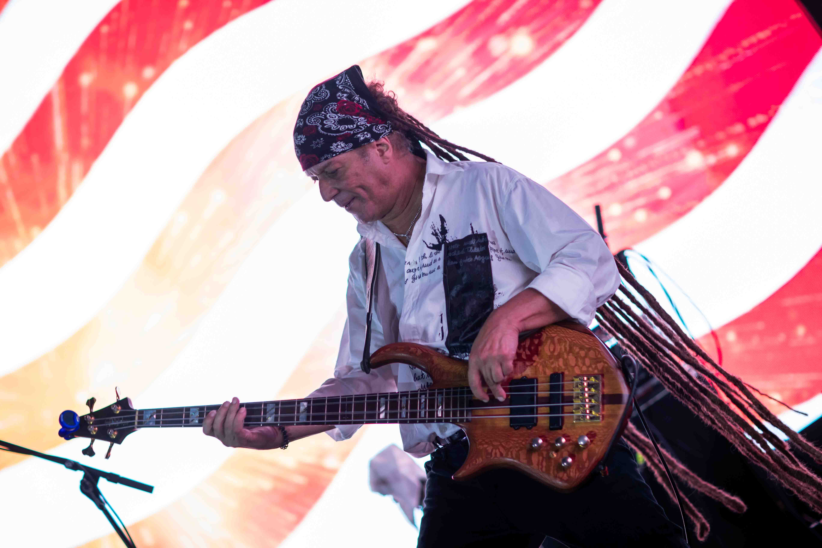

(Ends)

All images courtesy of 3DB. The high-resolution photos can be downloaded here.
To listen to music from Sonic Crusaders, please visit https://www.soniccrusaders.com/

About the Sennheiser brand
We live and breathe audio. We are driven by the passion to create audio solutions that make a difference. Building the future of audio and bringing remarkable sound experiences to our customers – this is what the Sennheiser brand has represented for more than 75 years. While professional audio solutions such as microphones, meeting solutions, streaming technologies and monitoring systems are part of the business of Sennheiser electronic GmbH & Co. KG, the business with consumer devices such as headphones, soundbars and speech-enhanced hearables is operated by Sonova Holding AG under the license of Sennheiser.

www.sennheiser.com
www.sennheiser-hearing.com

Global Pro Audio Press Contact
Stephanie Schmidt
stephanie.schmidt@sennheiser.com
+49 (5130) 600 – 1275

